Lab # 04

OBJECT

Examine the Functionality of the Network Address Translation

TOPOLOGY:

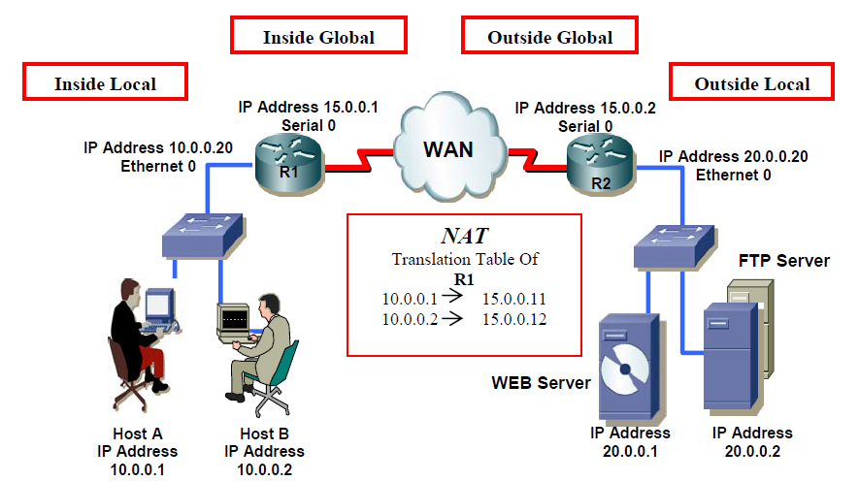

Part I: Static NAT

LAB TASK:

Q1) What command is used to verify NAT?
Ans)

Part II: Dynamic NAT

TOPOLOGY:

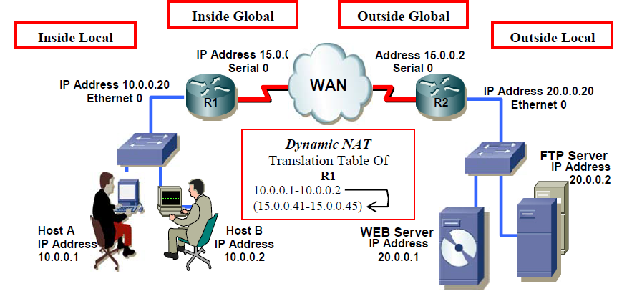

LAB TASK:

Q1) What command is used to clear NAT Table?
Ans)

